Bahria University,

Karachi Campus



COURSE: CSC-221 DATA STRUCTURES AND ALGORITHM

TERM: FALL 2020, CLASS: BSE- 3 (A)

Submitted By:

_______________________________________________

(ADIL WAHEED) (65190)

Submitted To:

Engr. Dr. Farah/ Engr. Ramshaa

Signed Remarks: Score:

INDEX

|  |  |  |  |  |
| --- | --- | --- | --- | --- |
| SNO | DATE | LAB NO | LAB OBJECTIVE | SIGN |
| 01 | 1-10-2020 | 01 | ONE AND TWO DIMENSIONAL ARRAY |  |
| 02 | 09-10-20 |  | Linear Search & Sorting Algorithms |  |
|  |  |  |  |  |
|  |  |  |  |  |
|  |  |  |  |  |
|  |  |  |  |  |
|  |  |  |  |  |
|  |  |  |  |  |
|  |  |  |  |  |
|  |  |  |  |  |
|  |  |  |  |  |
|  |  |  |  |  |
|  |  |  |  |  |
| SNO | DATE | LAB NO | LAB OBJECTIVE | SIGN |
|  |  |  |  |  |
|  |  |  |  |  |
|  |  |  |  |  |
|  |  |  |  |  |
|  |  |  |  |  |
|  |  |  |  |  |
|  |  |  |  |  |
|  |  |  |  |  |
|  |  |  |  |  |
|  |  |  |  |  |
|  |  |  |  |  |
|  |  |  |  |  |

Bahria University,

Karachi Campus



LAB EXPERIMENT NO.

_______

LIST OF TASKS

|  |  |
| --- | --- |
| TASK NO | OBJECTIVE |
| 01 | Which type of sorting you want to apply? Create a menu having the following options:   * 1. Bubble Sort Method   2. Selection Sort Method   3. Insertion Sort Method   Implement using methods. |
| 02 | Implement Selection sort and print string array data in descending order. |
| 03 | You have to write a program which take input from the user and place the value on correct location in ascending order. |
| 04 | Write a program which take N numbers of grocery items from user along with their price. Your main task is to display the items in sorted format. Then allow user to search for any of the item from that list by using name of the item. |
|  |  |
|  |  |
|  |  |
|  |  |
|  |  |
|  |  |

Submitted On:

____________

(Date: 09/10/20)

**Task No. 1:** Which type of sorting you want to apply? Create a menu having the following options:

1. Bubble Sort Method
2. Selection Sort Method
3. Insertion Sort Method

Implement using methods.

**Solution:**

string o;

do

{

Console.WriteLine("Which type of sorting you want to apply?");

Console.WriteLine("1)Bubble Sort Method\n2)Selection Sort Method\n3)Insertion Sort Method");

int a;

a =(Convert.ToInt32(Console.ReadLine()));

if (a == 1)

{

int[] array = new int[5];

int n = array.Length;

Console.WriteLine("====Bubble Sort=====");

Console.WriteLine("Enter Value only 5 index is avaliable ");

for (int i = 0; i < n; i++)

{

Console.WriteLine("Enter Value of {0}", i + 1);

array[i] = Convert.ToInt32(Console.ReadLine());

}

Console.WriteLine("user enter value:");

for (int i = 0; i < n; i++)

{

Console.Write("{0} ,", array[i]);

}

int k;

for (int m = n; m >= 0; m--)

{

for (int i = 0; i < n - 1; i++)

{

k = i + 1;

if (array[i] > array[k])

{

int temp;

temp = array[i];

array[i] = array[k];

array[k] = temp;

}

}

}

Console.WriteLine();

Console.WriteLine("sorted value:");

for (int i = 0; i < n; i++)

{

Console.Write("{0} ,", array[i]);

}

Console.WriteLine();

}

else if (a == 2)

{

int[] array = new int[5];

int n = array.Length;

Console.WriteLine("===Selection Sort====");

Console.WriteLine("Enter Value only 5 index is avaliable ");

for (int i = 0; i < n; i++)

{

Console.WriteLine("Enter Value of {0}", i + 1);

array[i] = Convert.ToInt32(Console.ReadLine());

}

Console.WriteLine("user enter value:");

for (int i = 0; i < n; i++)

{

Console.Write("{0} ,", array[i]);

}

int temp, smallest;

for (int i = 0; i < n - 1; i++)

{

smallest = i;

for (int j = i + 1; j < n; j++)

{

if (array[j] < array[smallest])

{

smallest = j;

}

}

temp = array[smallest];

array[smallest] = array[i];

array[i] = temp;

}

Console.WriteLine();

Console.WriteLine("sorted value:");

for (int i = 0; i < n; i++)

{

Console.Write("{0} ,", array[i]);

}

Console.WriteLine();

}

else if (a == 3)

{

int[] array = new int[5];

int n = array.Length;

Console.WriteLine("===Insertion Sort====");

Console.WriteLine("Enter Value only 5 index is avaliable ");

for (int i = 0; i < n; i++)

{

Console.WriteLine("Enter Value of {0}", i + 1);

array[i] = Convert.ToInt32(Console.ReadLine());

}

Console.WriteLine("user enter value:");

for (int i = 0; i < n; i++)

{

Console.Write("{0} ,", array[i]);

}

for (int i = 0; i < n - 1; i++)

{

for (int j = i + 1; j > 0; j--)

{

if (array[j - 1] > array[j])

{

int temp = array[j - 1];

array[j - 1] = array[j];

array[j] = temp;

}

}

}

Console.WriteLine();

Console.WriteLine("sorted value:");

for (int k = 0; k < n; k++)

{

Console.Write("{0} ,", array[k]);

}

Console.WriteLine();

}

else

{

Console.WriteLine("Please enter value from 1 to 3!!!");

}

Console.WriteLine("Do you want to another perform another operation y/n");

o = Convert.ToString(Console.ReadLine());

} while (o == "y" || o == "Y");

**Output:**

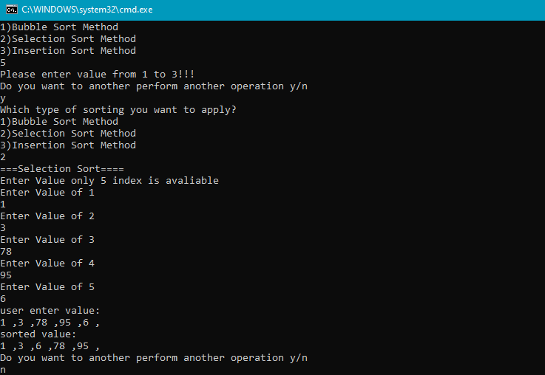

**Task No. 2:** Implement Selection sort and print string array data in descending order

**Solution:**

Console.WriteLine("which number of array is used?");

int n = Convert.ToInt32(Console.ReadLine());

int[] array = new int [n];

for (int i = 0; i < n; i++)

{

Console.WriteLine("Enter Value of {0}", i + 1);

array[i] = Convert.ToInt32(Console.ReadLine());

}

Console.WriteLine("user enter value:");

for (int i = 0; i < n; i++)

{

Console.Write("{0} ,", array[i]);

}

int temp, largest;

for (int i = 0; i < n - 1; i++)

{

largest = i;

for (int j = i + 1; j < n; j++)

{

if (array[largest] < array[j])

{

largest = j;

}

}

temp = array[largest];

array[largest] = array[i];

array[i] = temp;

}

Console.WriteLine();

Console.WriteLine("sorted value,Desending order:");

for (int k = 0; k < n; k++)

{

Console.Write("{0} ,", array[k]);

}

Console.WriteLine();

**Output:**

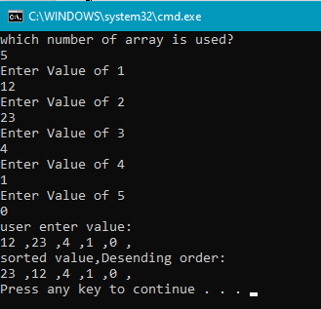

**Task No. 3:** You have to write a program which take input from the user and place the value on correct location in ascending order.

**Solution:**

int n;

Console.WriteLine("Enter a number");

n = Convert.ToInt32(Console.ReadLine());

int[] array = {3,2,5,4,8,n};

Console.WriteLine("values:");

for (int i = 0; i < array.Length-1; i++)

{

Console.Write("{0} ,", array[i]);

}

Console.WriteLine();

int k;

for (int m = array.Length; m >= 0; m--)

{

for (int i = 0; i < array.Length - 1; i++)

{

k = i + 1;

if (array[i] > array[k])

{

int temp;

temp = array[i];

array[i] = array[k];

array[k] = temp;

}

}

}

Console.WriteLine();

Console.WriteLine("ASCENDING ORDER:");

for (int i = 0; i < array.Length; i++)

{

Console.Write("{0} ,", array[i]);

}

Console.WriteLine();

**Output:**

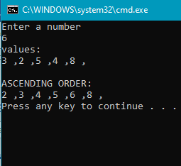

**Task No. 5:** Write a program which take N numbers of grocery items from user along with their price. Your main task is to display the items in sorted format. Then allow user to search for any of the item from that list by using name of the item.

**Solution:**

class Program

{

static void Insertion_sort(string[,] array)

{

string temp, name;

for(int i = 0; i < array.Length/2 - 1; i++)

{

for( int j = i+1; j > 0; j--)

{

float p1 = float.Parse(array[j-1,1]);

float p2 = float.Parse(array[j , 1]);

if(p1 > p2)

{

temp = array[j - 1, 1];

array[j-1 , 1] = array[j,1];

array[j, 1] = temp;

name = array[j-1, 0] ;

array[j - 1, 0] = array[j, 0];

array[j, 0] = name;

}

}

}

display(array);

}

static void display(string[,] array)

{

for (int i = 0; i < array.Length/2 ; i++)

{

Console.WriteLine( );

Console.WriteLine(" item name : \t"+ array[i,0] );

Console.WriteLine(" price : \t" + array[i, 1]);

Console.WriteLine();

}

}

static void selecting(String[,] array)

{

Console.Write(" want to find any item :");

char ans = Convert.ToChar(Console.ReadLine());

if (ans == 'Y'|| ans == 'y')

{ do

{

Console.Write(" enter item name : \t");

string name = Console.ReadLine();

for (int i = 0; i < array.Length / 2; i++)

{

if (name.ToLower() == array[i, 0])

{

Console.WriteLine();

Console.WriteLine("Item Found at {0}", i);

Console.WriteLine(" item name : \t" + array[i, 0]);

Console.WriteLine(" price : \t" + array[i, 1]);

Console.WriteLine();

}

}

Console.Write(" want to find any item :");

ans = Convert.ToChar(Console.ReadLine());

} while (ans == 'y' || ans == 'Y');

}

}

static void Main(string[] args)

{

Console.Write(" please enter the number of grocery items you want to enter in list : ");

int n = Convert.ToInt32(Console.ReadLine());

string[,] list = new string[n, 2];

for( int i = 0; i < list.Length/2; i++)

{

Console.Write(" enter name of item : ");

list[i, 0] = Console.ReadLine();

Console.Write(" enter price of item : ");

list[i, 1] = Console.ReadLine();

}

Insertion_sort(list);

selecting(list);

}

}

}

**Output:**

